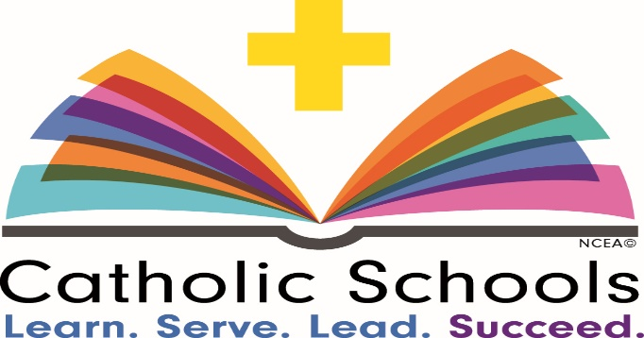
Saint Therese School
Catholic Schools Week 2018
January 28-February 3, 2018

Monday, January 29
- Student Dress: Pittsburgh Sports Dress Down Day
- Pittsburgh CLO Performance: Arriba, Arriba, The Roberto Clemente Story, 9:30AM
- Open House, 6-7:30PM to celebrate our great school! Current families, prospective families, alumni, parishioners and friends are invited to tour the school, check out the great classroom work and art work of our students and visit with our 6th and 7th grade scientists!
Tuesday, January 30
- Student Dress: Dress Up Day
- Serra Catholic High School students will visit Saint Therese to lead the Junior Achievement Program.
- Saint Anthony School Programs Students present Fine Dining during lunch periods

Wednesday, January 31
- Student Dress: All students 1-8 in REGULAR School Uniform (No Gym Uniforms)
- Mass at 9:30AM, Feast of St. John Bosco
- Grandparents/Special Persons invited to Mass at 9:30AM and then are invited to join us at school for lunch and activities.

Thursday, February 1
- Student Dress: Dress like your favorite book character day (K-5); High School or College T-Shirt Dress Down (6-8)
- Author Alan St. Jean visits Saint Therese School

Friday, February 2
- Student Dress: Spirit Day – Red/White/St. Therese Tigers Dress Down Day
- Winter Olympics activities in each department (K-2, 3-5, 6-8)

